Credential access lsass memory dump:
Since it is related to lsass.exe the keyword for search is lsass.exe. Observer the message an attempt was made to duplicate the handle of object and next message was handle object requested the object here is lsass.exe process name is Outflank-Dumpert.exe

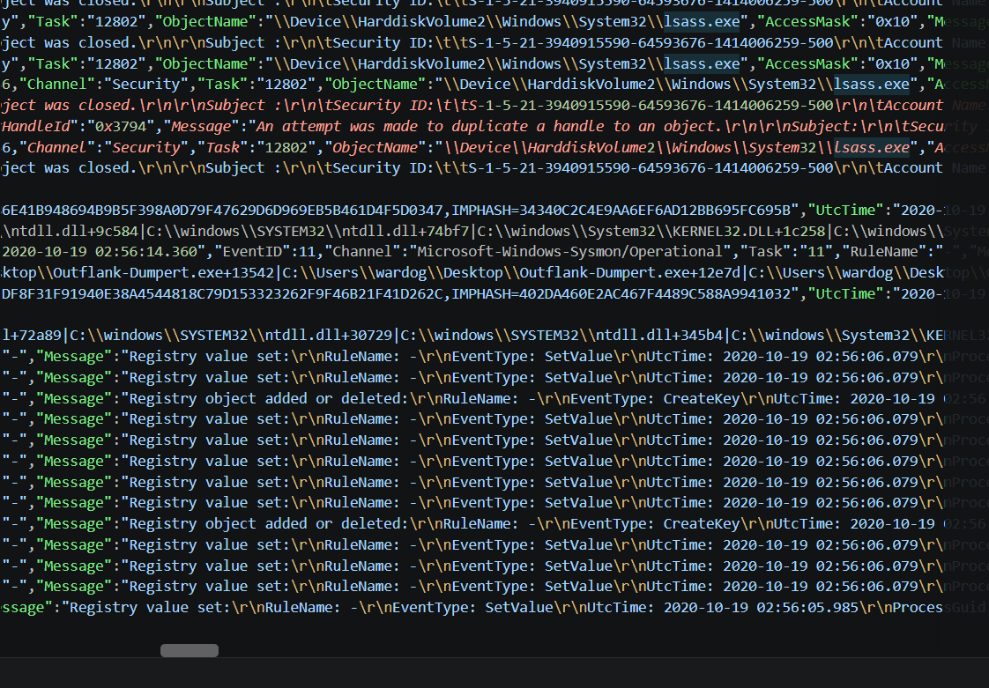

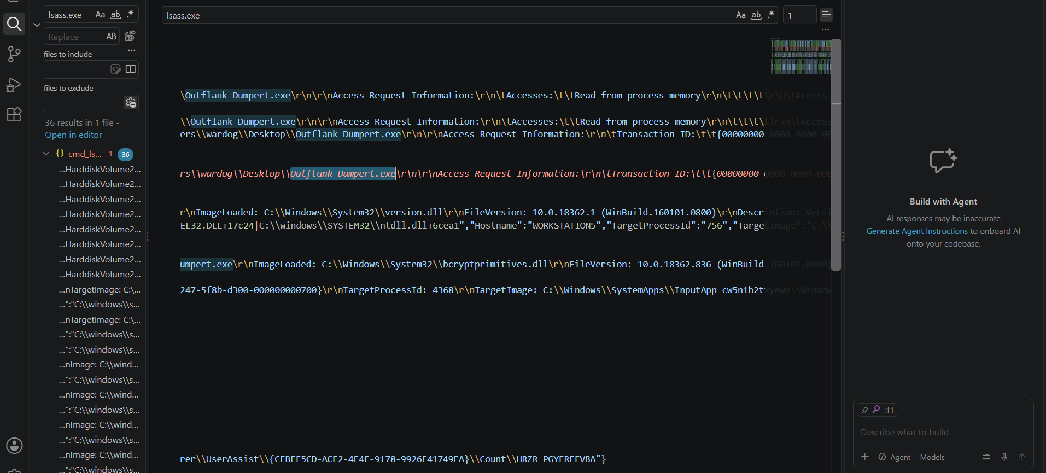

Next the image name is Outflank-Dumpert.exe whose original name is version.dll
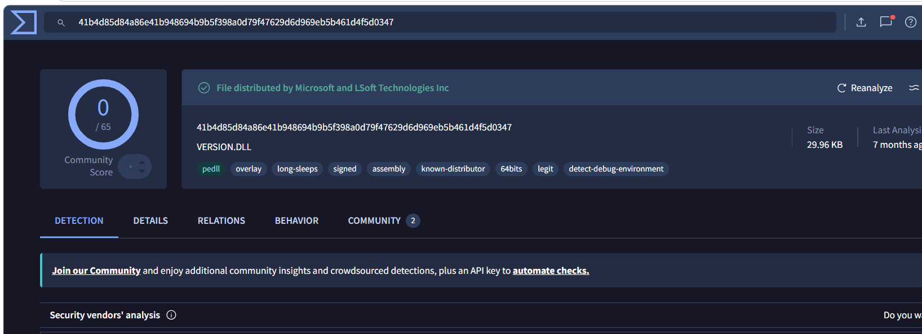

The Outflank-Dumpert.exe creates the dumpert.dmp file which is lsass dump as object name was lsass.
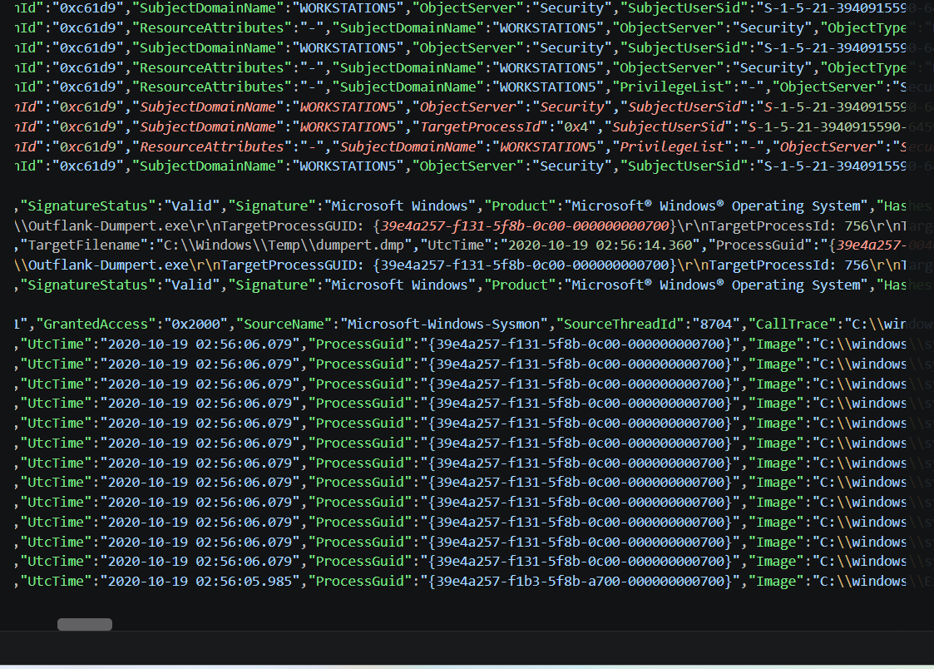

Followed by registry changes of W32Time\\SecureTimeLimits and caller of dmpert.dmp is Outflank-Dumpert.exe
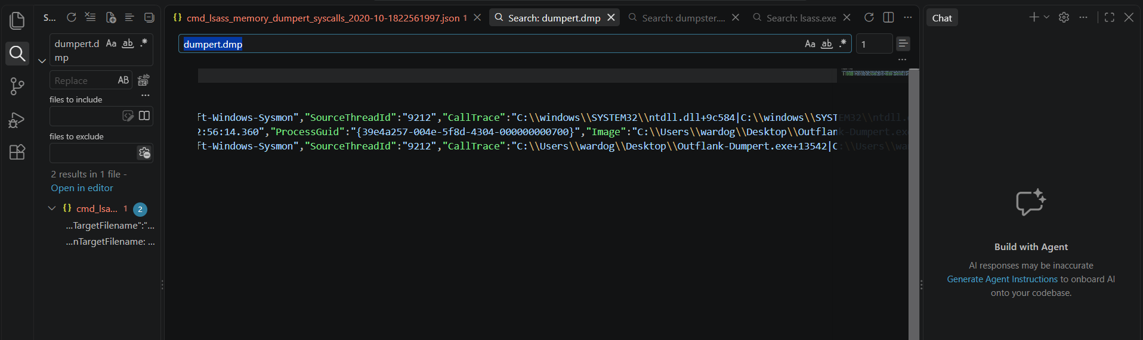

Overall activity. In this incident the Outflank-Dumpert.exe creates a duplicated handle of lsass.exe and creates the dumpert.dmp. This is followed by registry changes.

